WRIC Vendor Sharepoint Site

What Can I Find on this Site?
- This sharepoint site was developed to have a centralized placed for WRIC CCS program documents and shared resources.
- Types of Things you will find:
  - Program Manuals
  - FAQ/Guidance Documents
  - Example Templates and Forms
  - Training Resource Library
  - WRIC County Staff Directory
  - Upcoming Events and Meetings

How Can Staff Access this Site?
- To request access, email CCSsups@lacrossecounty.org.
  - Include the
    - 1) staff name,
    - 2) staff email address, and
    - 3) general function of the staff (e.g. owner/director, program lead, supervisor, staff member, trainer, fiscal, contracting, quality assurance, etc)

- At this time, each agency is allowed up to 3 persons that can be granted access to the sharepoint site.
  - Every 3 months, a user access audit will occur. Individuals who are not utilizing the site may lose their access to allow space for other users.
  - If a staff member leaves your agency, please notify the CCSsups@lacrossecounty.org to change access to another staff member.

  - Initial launch notes: given the current size of the WRIC network and needing to ensure data security, we are limiting the initial capacity to 300 users, which averages out to 3 users per agency. If your agency may need more users authorized, please include that request to the CCSsups@lacrossecounty.org and we can consider the request if other user slots are not utilized.

- Each user will have the ability to download and save any resources from the sharepoint site that may be shared with others within their agency.

- Authorized users on the sharepoint site will also be the recipients of consortia wide email notifications (the general WRIC Vendors email distribution list)
Any Tips or Tricks?
- Search Bar: If you aren’t sure where to find something, try the search bar at the top of the website. Type in words or phrases that might get you close to what you are looking for

  - 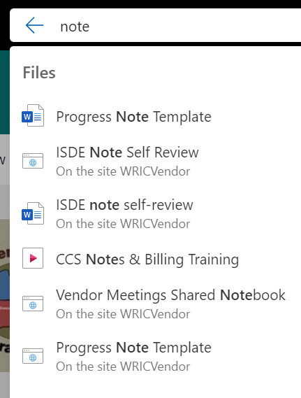

Any Tips or Tricks?
- Alerts & “Alert Me” - Each folder and library has an option to send you an email whenever a new item or resource is added
  - On the top head, after a folder or a file you should see 3 dots. Clicking the 3 dots opens more options for you to choose.
  - Select “Alert Me”
  - Choose how you would like to receive an alert (email or text message), what types of information would like an alert message on, how often you would like alerts
  - See visuals below:

    - 

     